Our project focuses on scaling monocular ORB_SLAM during initialization using a metric sensor, downward facing IR.

ORB_SLAM initializes with either Homography or Fundamental. Since both the methods are correct up-to scale, we are extracting the translation vector from the either of the two matrices and scaling it using the metric information from IR. We have implemented both the Homography and Fundamental matrix approach and extracted the translation vector from it. However, in our preliminary tests, the triangulated 3d points seem incorrect. The translation vector seems to be correct but isn’t scaling properly. Figure 1 shows the feature matches used to extract the fundamental followed by the essential matrix ().

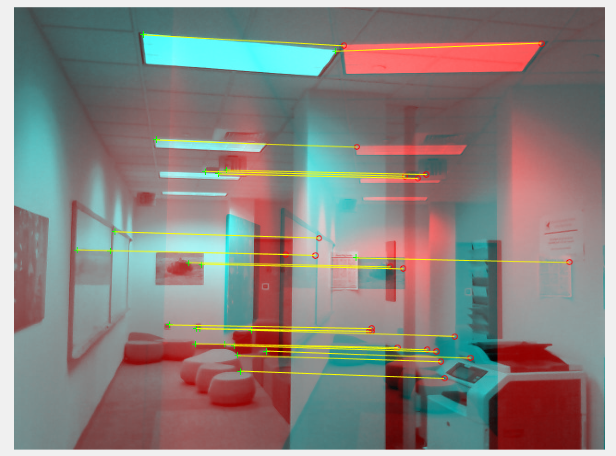

Figure 1: Feature Matches

When extracting rotation and translation from the essential matrix, there are four potential transformations, neither of which seems to be correct. Although the relative positions of the camera matches those used to take the images, but when triangulated, the points look bizarre. This is shown in figure 2. We are working on similar problems in the homography case. 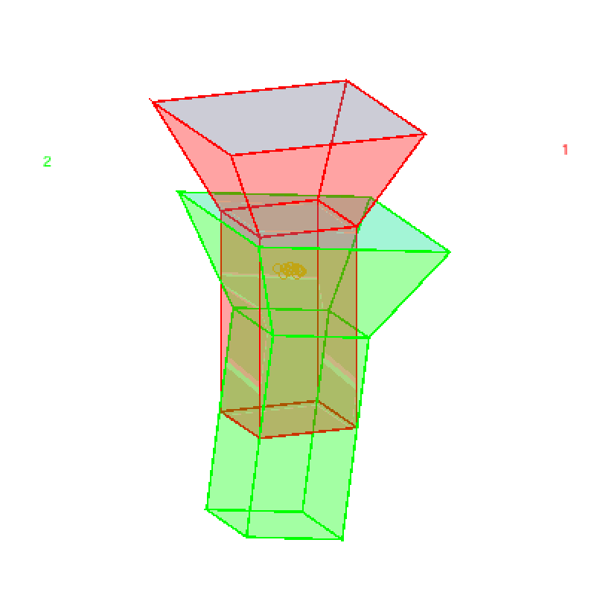

Figure 2: Relative Camera motion with triangulated points

Sensor & Validation Setup

The sensor setup is shown in Figure 4. The sensor setup contains a Kinect RGB-D sensor to enable both RGB-D and monocular SLAM, an UM7 IMU and 2 Sharp distance sensors mounted underneath. The IMU is used to accept or reject distance readings since we need to have near-zero roll and pitch to obtain good distance readings with respect to the ground, and a simple bubble level is used to help the user acquire useful data by keeping the sensor level. We have acquired an initial dataset to perform RGB-D Slam using ORB-SLAM, which will be used as a basis of comparison against our modified monocular ORB-SLAM. RGB-D ORB-SLAM was successful tracking using the depth image from the kinect, shown in Figure 3. We have extracted the key frame map points to create a sparse pointcloud of the scene, and will eventually use that as a basis of comparison.

Figure 1: RGB-D ORB-SLAM results using sensor rig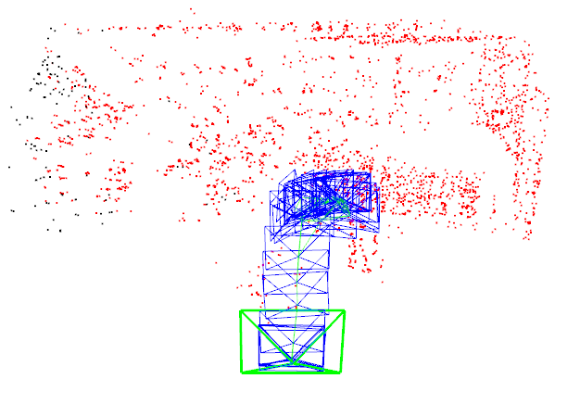

Figure 1: Sensor Rig ( Sharp distance sensors mounted underneath)